**Sequence Models**

Alert for appointment

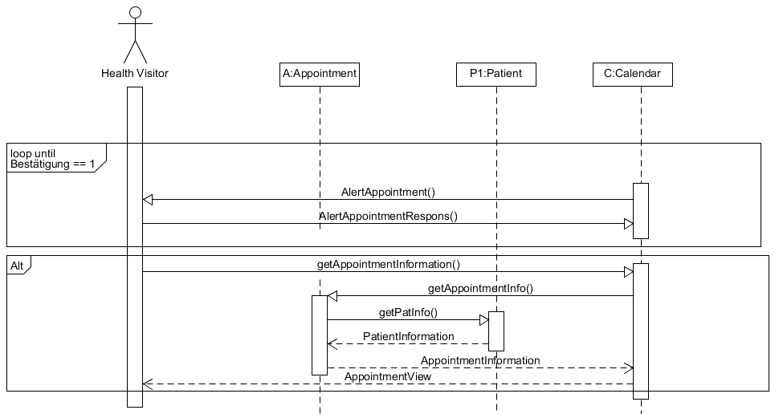

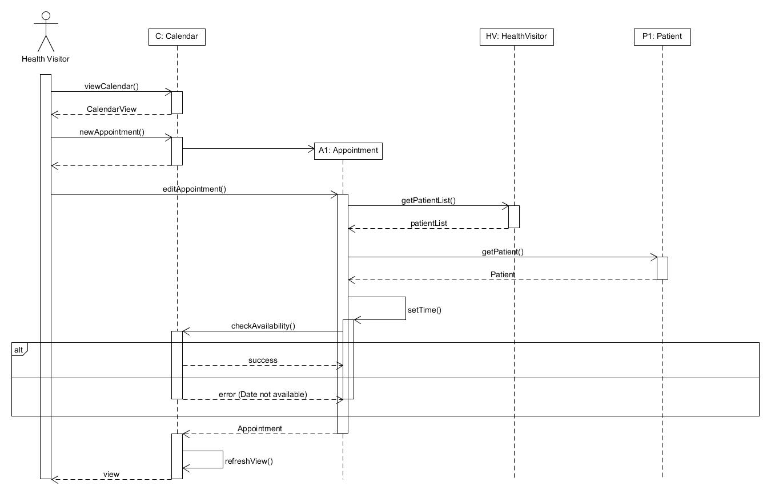Updating calendar: Create new appointment